Crossroad Logic Simulation and PCB Implementation
Formal Verification of the Otoka Intersection Traffic-Light Controller
Course: Formal Models | Faculty of Electrical Engineering, University of Sarajevo
Emin Hadžiabdić (19960) · Armin Memišević (20016) · Muhammed Pašić (20109)
Academic Year 2025/26 · Supervisor: Prof. Dr. Aida Branković

1. Introduction: the problem at the Otoka crossroad
The Otoka intersection in Sarajevo joins Bulevar Meše Selimovića, the main east–west boulevard carrying through traffic between Ilidža and Stari Grad, with the north–south side approaches from Buća Potok and Aneks. It is a high-volume junction where two streams of traffic must use the same physical conflict zone without ever occupying it at the same time.
A traffic-light controller for such a junction is a safety-critical reactive system. Its correctness is not a matter of average behaviour: a controller that sequences correctly 99.9% of the time is not acceptable, because the remaining 0.1% is a collision. Three requirements follow directly from the physical situation:
- No conflicting movement may ever be permitted simultaneously. Green on the boulevard and green on the side street must be mutually exclusive at all times, not merely under normal operation.
- No approach may be starved. A driver waiting at a red light must be guaranteed a green within a bounded number of steps, otherwise the junction deadlocks in practice even if it is electrically alive.
- Phase changes must be gradual. A green may never become a red without an intervening yellow, because an abrupt change causes rear-end collisions at the stop line.
These are exactly the properties that formal models are built to express and discharge. Testing a physical board can show that a fault did not occur during the observation window; it cannot show that the fault is impossible. This project therefore takes the opposite route. We first specify the controller as a formal object, prove the three requirements above as theorems about that object, and only then map the proven design onto discrete logic and fabricate it as a printed circuit board. The report presents that chain: specification, proof, and physical realisation.

1.1 What we set out to prove
Five properties were targeted. Each is stated informally here and formalised in Section 4.
Property | Informal statement
Safety | Two conflicting greens are never active at the same time.
Liveness | Every red approach eventually receives a green.
Deadlock-freedom | The controller never reaches a state with no outgoing transition.
Reachability | Every designed traffic phase is actually attainable from power-on, and no undesigned phase is.
Crash-state unreachability | The specific marking representing two simultaneous greens admits no firing sequence from the initial state.

2. Formal models used, and why each one was chosen
Four models were applied. They are not four views of the same proof; each was selected because it is the natural setting for a property the others express poorly. The motivation for each choice is given below, followed by a summary table.
A labelled transition system (LTS) was chosen first because the controller is, at bottom, a finite deterministic sequencer. Reachability and deadlock-freedom are properties of the transition graph itself, and in an LTS they reduce to graph facts that can be checked by inspection: which vertices are reachable from the initial vertex, and whether any vertex has out-degree zero. Bringing a heavier formalism to these two questions would add machinery without adding rigour.
A Petri net was chosen for the resource-level argument. The LTS proves that the abstract state never equals a bad state, but it says nothing about the six physical lamps, because in the LTS the lamps are only labels. The Petri net promotes each lamp to a place holding a token when it is energised, which turns "the two greens are never on together" into a statement about token distribution. This is what makes structural invariants available: the P-invariants bound each approach to exactly one active lamp for every reachable marking, and the state equation converts the crash question into a linear algebra problem with a decidable answer. The T-invariant then proves cyclicity, which is the structural counterpart of liveness.
Linear temporal logic (LTL) was chosen because two of the requirements are explicitly about time. "Eventually green" and "yellow on the next tick" are temporal-operator statements (F and X) that propositional logic cannot express, since a lamp's truth value changes from tick to tick. LTL also lets the proofs be discharged directly against the Boolean output equations of the actual gates rather than against an abstraction, which is the closest link we have between a temporal specification and the soldered hardware.
A Markov reward process (MRP) was chosen last, to relax the assumption that the hardware is perfect. Every model above assumes the flip-flops always land in the intended state. Real CMOS memory can be disturbed by supply noise or a marginal clock edge. Making the transition stochastic tests whether safety is a property of the design or merely of undisturbed operation, and the associated Bellman utilities give a quantitative check that no state is a sink. A full Markov decision process would be the wrong tool: the board takes no actions and has no policy to optimise, so an action-less MRP is the correct restriction.
Model | Property discharged | Why this model
LTS / Moore FSM | Reachability, deadlock-freedom | Both are graph properties of the transition relation; an LTS states them directly.
Petri net | Safety (structural), boundedness, liveness, crash-state unreachability | Promotes lamps to token-holding resources, giving P-/T-invariants and a decidable state equation.
LTL | Safety, liveness, strict sequencing | Only formalism here that expresses "eventually" and "next"; discharged against the real gate equations.
Markov reward process | Probabilistic safety, expected liveness | Tests robustness under stochastic bit-flips; action-less, so Bellman stays linear.

3. System design

3.1 State definition and encoding
The controller is a synchronous Moore machine with four states. Outputs depend on the current state alone, which prevents input glitches from propagating to the lamps. Two bits of state are required; they are held in the two D-type flip-flops of a single 74HCT74. To avoid confusion between state names and state bits, the memory bits are written Q1 and Q0 throughout this report.
State | Q1 Q0 | East–West (Bulevar M. Selimovića) | North–South (Buća Potok / Aneks)
S0 | 0 0 | GREEN | RED
S1 | 0 1 | YELLOW | RED
S2 | 1 0 | RED | GREEN
S3 | 1 1 | RED | YELLOW
Table 1 — State encoding. The encoding was chosen so that the sequence is a plain 2-bit up-count, which minimises next-state logic.
The critical design decision is visible in the table. Because S0 and S2 are the only green states and they differ in Q1, and because the four output minterms of (Q1, Q0) are mutually exclusive by construction, conflicting greens are excluded by the encoding itself rather than by any transition rule. Section 4.3 turns this observation into a formal proof.
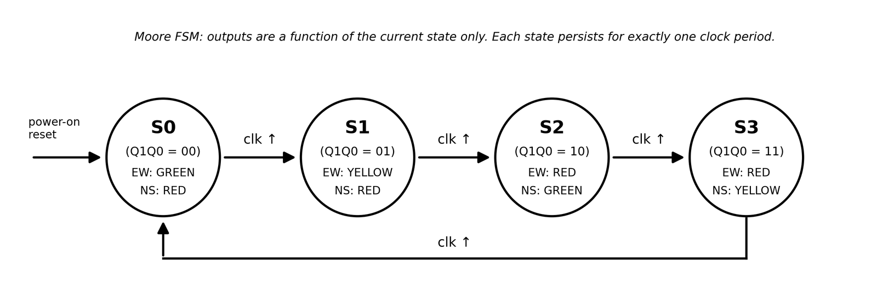
Figure 1 — FSM state diagram with binary encoding and Moore outputs. Transitions occur on the rising edge of the externally supplied clock.

3.2 Transition and output table
The next-state columns give the required flip-flop excitations D1 and D0, since for a D flip-flop the excitation equals the desired next state.
Q1 | Q0 | D1 | D0 | REW | YEW | GEW | RNS | YNS | GNS
0 | 0 | 0 | 1 | 0 | 0 | 1 | 1 | 0 | 0
0 | 1 | 1 | 0 | 0 | 1 | 0 | 1 | 0 | 0
1 | 0 | 1 | 1 | 1 | 0 | 0 | 0 | 0 | 1
1 | 1 | 0 | 0 | 1 | 0 | 0 | 0 | 1 | 0
Table 2 — FSM transition and output table. Exactly one of GEW, YEW, GNS, YNS is high in every row.
The same information is easier to check as a time sequence. Figure 2 lays the four phases out against the clock, with the lamp aspect of each approach shown directly.
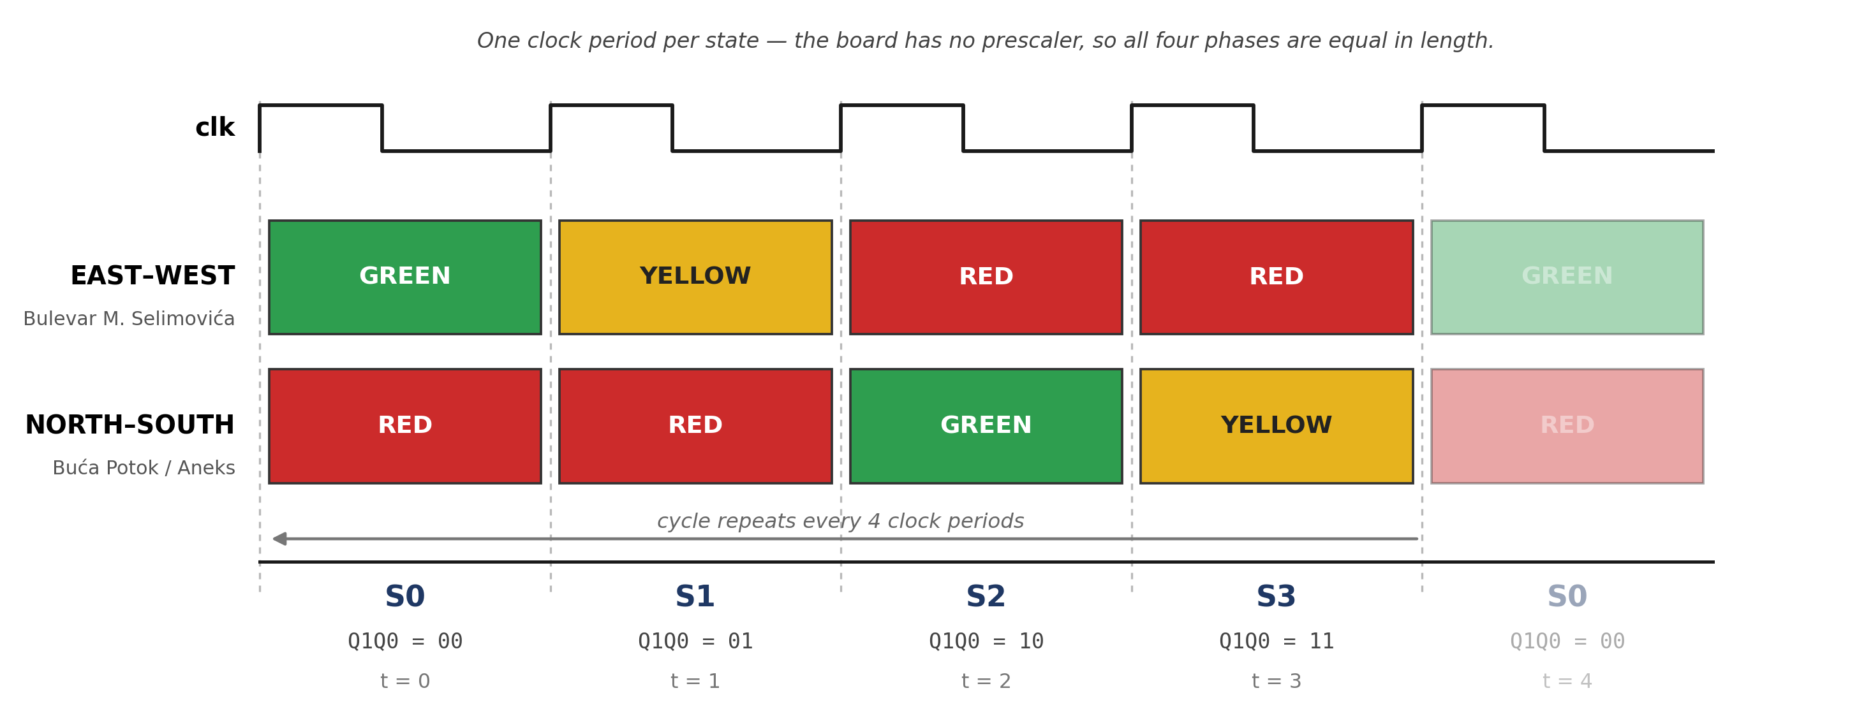
Figure 2 — State-sequence timeline over one full cycle. Reading down any column shows that the two approaches never display green together, and reading across shows that every green is followed by a yellow before red.

3.3 Karnaugh-map derivation of the next-state logic
Two 2-variable K-maps minimise the flip-flop inputs.
K-map for D1:
Q1 \ Q0 | 0 | 1
0 | 0 | 1
1 | 1 | 0
The two 1s sit on the diagonal, so no adjacent pair can be grouped. This is the checkerboard pattern of an exclusive-OR, and the minimal form is obtained by writing both minterms and factoring:
D1 = (¬Q1 · Q0) + (Q1 · ¬Q0) = Q1 ⊕ Q0
K-map for D0:
Q1 \ Q0 | 0 | 1
0 | 1 | 0
1 | 1 | 0
The entire left column groups into a single pair. Q1 changes across the group and is therefore eliminated, leaving only the complement of Q0:
D0 = ¬Q0
Table 3 — K-maps for the flip-flop excitations D1 and D0.
The output K-maps are read the same way. REW is 1 across the whole bottom row, so REW = Q1; RNS is 1 across the whole top row, so RNS = ¬Q1. Each of the four remaining outputs is true in exactly one state, so each is a single minterm and needs one AND gate.

3.4 Final minimised logic equations
D1 = Q1 ⊕ Q0
D0 = ¬Q0
GEW = ¬Q1 · ¬Q0 YEW = ¬Q1 · Q0 REW = Q1
GNS = Q1 · ¬Q0 YNS = Q1 · Q0 RNS = ¬Q1
The design uses no OR gates at any point. This was not a constraint imposed at the outset; the project proposal anticipated AND/OR logic. It is a consequence of the up-count encoding, which reduces every output to a single minterm and the next-state logic to one XOR and one inverter.

3.5 Mapping to physical hardware
Function | Device | Gates required (logic) | Gates instantiated | Package capacity
State memory (Q1, Q0) | 74HCT74 dual D flip-flop | 2 | 2 | 2
Output minterms | 74HC08 quad 2-input AND | 4 | 4 | 4
Complements ¬Q1, ¬Q0 | 74HCT04 hex inverter | 2 | 4 | 6
Next-state D1 | 74HCT86 quad 2-input XOR | 1 | 1 | 4
Clock generation | NE555 astable (R13, R14, C1, C2) | 1 | 1 | 1
Table 4 — Device budget. The 74HC08 is fully consumed; the inverter and XOR packages carry spare gates.
The four AND outputs and the two red-lamp drivers feed twelve 5 mm LEDs, each through its own 330 Ω series resistor. The junction has four light heads, so every logic signal fans out to two physical LEDs. Power enters on a 2-pin screw terminal at 5 V DC, taken either from a USB power bank via a cut USB lead or from a 4-cell AA holder; D13, a 1N4007 in series with the incoming positive lead, provides reverse-polarity protection.
The clock is generated on the board itself. U1 is an NE555 wired as a free-running astable oscillator: R13 sits between the supply and the discharge pin, R14 between the discharge pin and the joined trigger and threshold pins, and C1 from that node to ground, with C2 bypassing the control-voltage pin. The 555 output drives the CLK inputs of both flip-flops directly. This was verified by extracting the netlist from the schematic rather than read off the drawing: the oscillator output, and only that output, reaches both clock pins. The rate is fixed by the values fitted for R13, R14 and C1; there is no potentiometer, so changing it means changing components.
The netlist extraction also settles the asynchronous inputs. Both flip-flops have their active-low Set and Reset pins on the supply net, together with the 555 reset pin, so no asynchronous input is ever asserted and the clocked path cannot be overridden. This matters for the liveness argument in Section 4.3.
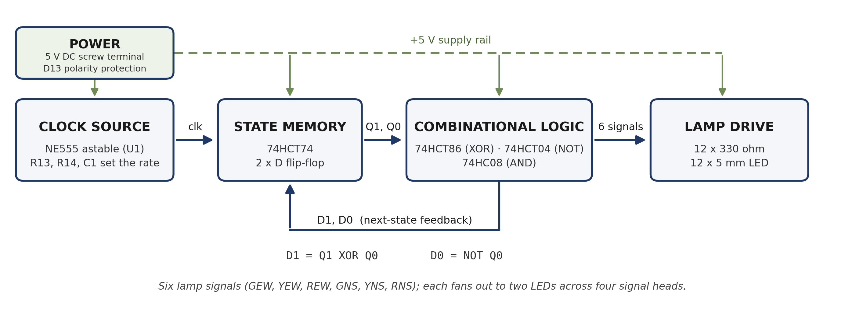
Figure 3 — System block diagram. The on-board NE555 astable clocks the state register; the register output feeds the combinational layer, which both drives the lamps and computes the next state fed back to the flip-flop D inputs.
The inverter count deserves a plain statement. The minimised equations need only two complemented signals, ¬Q1 and ¬Q0, and both are already available at no cost on the Q̄ pins of the 74HCT74. Four inverters are instantiated instead, and the netlist confirms that all of them take their input from the Q outputs; the Q̄ pins are left unconnected. The two extra inverters are spare capacity in a hex package rather than a logic requirement. Table 4 reports the instantiated and the required counts separately for that reason.
The gate-level realisation of these equations is given by the project schematic, reproduced as Figure 4. It shows the NE555 oscillator and its timing network, both flip-flops with their clock, Set and Reset connections, the XOR feeding D1, the inverter bank, the four AND gates producing the output minterms, and the twelve LED branches with their series resistors.
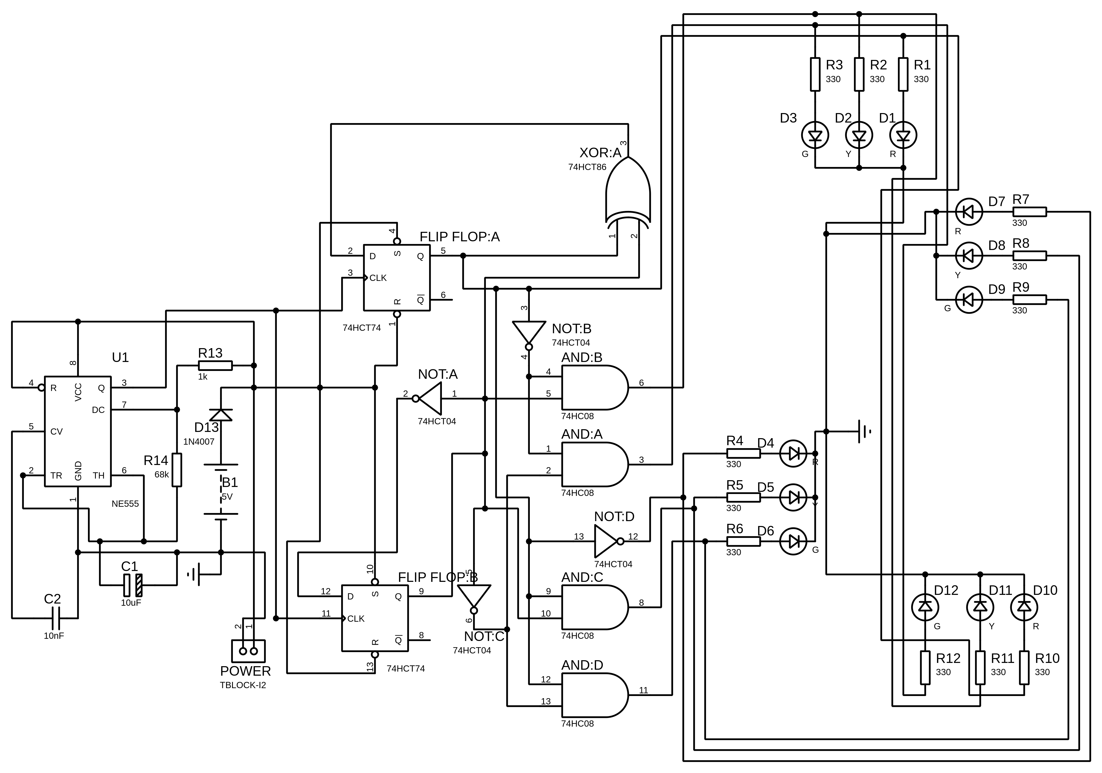
Figure 4 — Gate-level schematic. U1 (NE555) with R13, R14, C1 and C2 forms the clock; its output drives both CLK pins of the 74HCT74. The 74HCT86 XOR generates D1, the 74HCT04 inverter bank supplies the complements, and four 74HC08 AND gates generate the output minterms feeding the twelve LED branches. Power arrives on the single 2-pin screw terminal, protected by D13. B1 is a simulation source and has no counterpart on the board.

4. Formal verification

4.1 Labelled transition system
The controller is the LTS (Proc, Act, →) with Proc = {S0, S1, S2, S3}, Act = {clk}, and
→ = { (S0, clk, S1), (S1, clk, S2), (S2, clk, S3), (S3, clk, S0) }
Reachability. From the power-on state S0 the trace ⟨clk⟩ reaches S1, ⟨clk, clk⟩ reaches S2 and ⟨clk, clk, clk⟩ reaches S3. The reachable set is therefore exactly {S0, S1, S2, S3}: every designed phase is attainable and, since Proc has only four elements, no undesigned phase exists.
Deadlock-freedom. A state deadlocks if its out-degree is zero. Inspecting →, every state has exactly one outgoing edge, so ∀ s ∈ Proc, ∃ s′ ∈ Proc with s →clk s′. No state can freeze.
Determinism and cyclicity. Every state also has out-degree exactly one, so the machine is deterministic and the transition graph is a single 4-cycle. After four clock pulses the system returns to S0 and repeats indefinitely, which is the desired behaviour for a continuously operating reactive controller.

4.2 Petri net model and structural proofs
The net has six places, one per lamp, P = {pGEW, pYEW, pREW, pGNS, pYNS, pRNS}, and four transitions T = {t1, t2, t3, t4}, one per clock-driven phase change. A token in a place means that lamp is energised. At power-on the boulevard is green and the side street is red, so
M0 = (1, 0, 0, 0, 0, 1)ᵀ ordering (GEW, YEW, REW, GNS, YNS, RNS)
Modelling justification. Places represent the active lamps rather than the abstract states. This is deliberate: it is what allows the collision requirement to be expressed as a bound on token distribution across physical resources, which is the form the invariant machinery can act on.
The arcs are given compactly as consumed → produced sets:
t1: {pGEW} → {pYEW}
t2: {pYEW, pRNS} → {pREW, pGNS}
t3: {pGNS} → {pYNS}
t4: {pREW, pYNS} → {pGEW, pRNS}
Subtracting the Pre matrix from the Post matrix gives the incidence matrix C = Post − Pre, whose entry (p, t) is the net token change at place p when transition t fires.
Place | t1 | t2 | t3 | t4
pGEW | −1 | 0 | 0 | +1
pYEW | +1 | −1 | 0 | 0
pREW | 0 | +1 | 0 | −1
pGNS | 0 | +1 | −1 | 0
pYNS | 0 | 0 | +1 | −1
pRNS | 0 | −1 | 0 | +1
Table 5 — Incidence matrix C (6 places × 4 transitions).
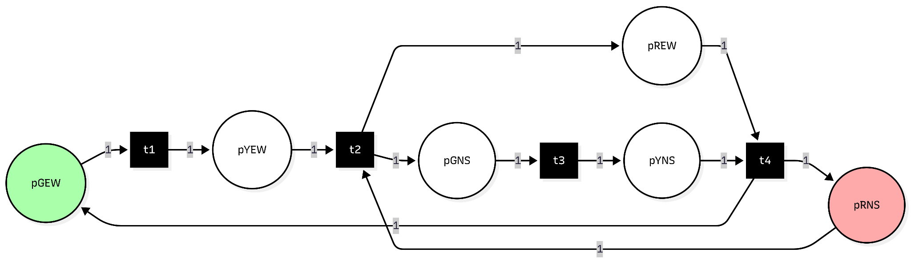
Figure 5 — Petri net of the controller. Six places (lamps), four transitions (clock pulses). The initial marking M0 places one token in pGEW and one in pRNS.
Determinism of the firing sequence. A transition t is enabled at M iff Pre[:, t] ≤ M. At M0 only t1 qualifies, since t2 additionally requires a token in pYEW; at M1 = (0,1,0,0,0,1)ᵀ only t2; at M2 = (0,0,1,1,0,0)ᵀ only t3; at M3 = (0,0,1,0,1,0)ᵀ only t4. No reachable marking enables more than one transition, so the net has neither conflict nor concurrency, and σ = t1 t2 t3 t4 is the unique firing sequence from M0. The reachable set R(N, M0) therefore contains exactly these four markings and nothing else.
Liveness and deadlock-freedom (T-invariant). Solving C·y = 0 gives a null space that is exactly one-dimensional, spanned by
y = (1, 1, 1, 1)ᵀ
so this is the unique minimal T-invariant. Because it is strictly positive, firing each transition exactly once returns the net to M0. The two properties are distinct and worth separating: deadlock-freedom means every reachable marking has at least one enabled transition, whereas liveness means every transition can eventually fire again from every reachable marking. Here the T-invariant establishes both, since every transition fires exactly once per cycle and the cycle repeats forever.
Boundedness and structural safety (P-invariants). P-invariants satisfy Cᵀ·x = 0. The null space of Cᵀ is three-dimensional; two of its members carry the safety argument:
x1 = (1, 1, 1, 0, 0, 0)ᵀ ⇒ M(pGEW) + M(pYEW) + M(pREW) = 1
x2 = (0, 0, 0, 1, 1, 1)ᵀ ⇒ M(pGNS) + M(pYNS) + M(pRNS) = 1
Each invariant sums to 1 under M0 and is therefore conserved at 1 for every reachable marking. Each approach thus carries exactly one active lamp at all times: never zero (a dark signal head) and never two (contradictory aspects on one pole). Since no place can exceed 1, the net is 1-bounded, which is the definition of a safe Petri net.
Two further members of the same null space are worth naming, because they are sometimes mistaken for competing results. The vector x = (1,1,1,1,1,1)ᵀ is simply x1 + x2 and gives the weaker statement that the total token count is constant at 2. It alone does not prove 1-boundedness, since it does not exclude one place holding both tokens; the split invariants are required for that. The third independent invariant, x3 = (0,0,1,0,0,1)ᵀ, gives M(pREW) + M(pRNS) = 1, meaning exactly one approach shows red at any instant. All of these are different bases of the same three-dimensional space, not conflicting findings.
Crash-state unreachability (state equation). Let the crash marking be two simultaneous greens:
Mcrash = (1, 0, 0, 1, 0, 0)ᵀ , Mcrash − M0 = (0, 0, 0, 1, 0, −1)ᵀ
A marking is reachable only if the state equation M = M0 + C·n admits a non-negative integer firing vector n. Writing C·n = Mcrash − M0 row by row gives:
(1) −n1 + n4 = 0 (4) n2 − n3 = 1
(2) n1 − n2 = 0 (5) n3 − n4 = 0
(3) n2 − n4 = 0 (6) −n2 + n4 = −1
Equations (1), (2), (3) and (5) force n1 = n2 = n3 = n4. Substituting n2 = n3 into (4) yields n3 − n3 = 1, that is 0 = 1. Substituting n2 = n4 into (6) yields −n4 + n4 = −1, that is 0 = −1. The system is inconsistent, so no firing vector exists over the integers, let alone over the non-negative integers. Because the state equation is a necessary condition for reachability, its infeasibility proves the crash marking is unreachable. Equivalently, rank(C) = 3 while rank([C | Mcrash − M0]) = 4, so by the Rouché–Capelli criterion the system has no solution.
This is the strongest of our safety results, because it is a statement about the structure of the net rather than about any particular execution.

4.3 Linear temporal logic
A time step is one rising edge of the on-board oscillator. Atomic propositions are the six lamp signals, each identified with the Boolean output equation that drives it, so the proofs below are discharged against the actual gate logic.
Property 1 — Absolute safety (collision avoidance).
G ¬(GEW ∧ GNS)
Proof by combinational tautology. From Section 3.4, GEW = ¬Q1 · ¬Q0 and GNS = Q1 · ¬Q0. Substituting into the property:
¬( (¬Q1 ∧ ¬Q0) ∧ (Q1 ∧ ¬Q0) ) = ¬( (¬Q1 ∧ Q1) ∧ ¬Q0 ) = ¬(0 ∧ ¬Q0) = ¬0 = 1
The conjunction contains Q1 and ¬Q1, which is a contradiction for either value of Q1. The formula therefore evaluates to true across all 2² = 4 assignments of the state bits. This is stronger than a reachability argument: overlapping greens are excluded by the gate equations themselves, so the property holds even for the two states the controller is not supposed to be in and even if a fault placed it there.
A bounded model check confirms the same conclusion behaviourally. The BMC query asks whether a trace of length k starting at I(s0) = (Q1=0 ∧ Q0=0) and following the transition relation can reach ¬P, where P := ¬(GEW ∧ GNS). At k = 1 the only successor is S1 (01), where GEW = 0 and GNS = 0; at k = 2 it is S2 (10) with GEW = 0; at k = 3 it is S3 (11) with both low; at k = 4 the system is back at S0 (00) with GNS = 0. Every query is unsatisfiable, and because the machine is a deterministic 4-cycle, k = 4 already exhausts the reachable state space. No counterexample exists at any bound, including as k → ∞.
Property 2 — Liveness (no traffic starvation).
G ( RNS ⇒ F GNS )
Proof by state-bit tracing. RNS = ¬Q1 is true exactly in states 00 and 01. The 74HCT86 and 74HCT04 implement D1 = Q1 ⊕ Q0 and D0 = ¬Q0, which is an unconditional 2-bit up-counter, so the bits advance 00 → 01 → 10 regardless of any external condition. In state 10 the logic gives GNS = Q1 · ¬Q0 = 1. A vehicle waiting on the Buća Potok approach therefore receives a green within at most two clock periods, so F(GNS) holds and liveness is guaranteed. The fairness assumption required by LTL for infinite paths is that clock pulses keep arriving. Because the oscillator is on the board and free-running, that assumption is discharged by the hardware itself rather than deferred to an external instrument.
The argument above additionally requires that no asynchronous input can interrupt the count. The 74HCT74 has active-low Set and Reset pins which, if asserted, would override the clocked path entirely. All four of these pins were traced to the supply net when the schematic netlist was extracted, so neither is ever asserted and the count cannot be interrupted. The premise of the proof is therefore a checked fact about the board rather than an assumption.
Property 3 — Strict sequencing (no abrupt green-to-red).
G ( GEW ⇒ X YEW )
Proof by next-state logic. The X operator evaluates the state immediately after the current clock edge. GEW is true exactly when (Q1, Q0) = (0, 0). The characteristic equations give the next state D1 = 0 ⊕ 0 = 0 and D0 = ¬0 = 1, so the successor is unconditionally (0, 1). In that state YEW = ¬Q1 · Q0 = 1. The memory cannot go from 00 directly to 10, because that would require D0 = 0 while Q0 = 0, contradicting D0 = ¬Q0. The yellow interval is therefore enforced by the structure of the next-state logic and cannot be skipped. The symmetric argument holds for GNS ⇒ X YNS, since (1,0) advances to (1,1) where YNS = Q1 · Q0 = 1.

4.4 Markov reward process and stochastic robustness
All proofs so far assume the memory always lands where the logic says it should. To test whether safety survives imperfect hardware, the controller is re-modelled as a discrete-time Markov reward process. An MRP rather than a full MDP is the correct choice, because the board selects no actions; this matters for the solution method, as shown below.
The intended transition is assigned probability 0.97, with the residual 0.03 distributed evenly (0.01 each) over the three remaining valid states, which includes the possibility of the state failing to advance at all. A fifth state SCrash is added to represent two simultaneous greens. Rewards are +10 for the green-carrying states S0 and S2 (traffic is flowing) and −1 for the yellow states S1 and S3 (traffic is slowing). The reward magnitudes and the discount factor γ = 0.9 are modelling choices, not measured quantities; the conclusions below depend on their signs and relative order, not their exact values.
From \ To | S0 | S1 | S2 | S3 | SCrash
S0 | 0.01 | 0.97 | 0.01 | 0.01 | 0.00
S1 | 0.01 | 0.01 | 0.97 | 0.01 | 0.00
S2 | 0.01 | 0.01 | 0.01 | 0.97 | 0.00
S3 | 0.97 | 0.01 | 0.01 | 0.01 | 0.00
SCrash | 0.00 | 0.00 | 0.00 | 0.00 | 1.00
Table 6 — Stochastic transition matrix P. Every row sums to exactly 1.00.
Probabilistic safety. The SCrash column is identically zero for all four operational states, so P^k has a zero SCrash column for every k and the crash probability remains exactly 0 as k → ∞. It should be stated plainly that this is a consistency check rather than an independent proof: the column is zero because the encoding admits no crash state to transition into, and the substantive argument for that is the combinational tautology of Property 1. What the Markov model adds is the observation that safety does not depend on the transitions being correct. Even when 3% of clock edges send the machine to an unintended state, every one of those states is still one of the four safe encodings, so no glitch can produce a collision.
Expected liveness via the Bellman equation. For a state s,
U(s) = R(s) + γ · Σ_{s′} P(s′ | s) · U(s′)
Bellman equations normally require value iteration because of the non-linear max operator over actions. In an action-less MRP that operator disappears, leaving a linear system that can be solved exactly. The four-state system reduces by the symmetry U(S0) = U(S2), U(S1) = U(S3), which is not an assumption imposed on the model but a consequence of it: solving the unreduced four-equation system yields the same values. Writing A = U(S0) and B = U(S1):
A = 10 + 0.9 · (0.02·A + 0.98·B) = 10 + 0.018·A + 0.882·B
B = −1 + 0.9 · (0.98·A + 0.02·B) = −1 + 0.882·A + 0.018·B
Adding the two equations gives 0.1(A + B) = 9, hence A + B = 90 exactly. Subtracting them gives 1.864(A − B) = 11. Solving:
U(S0) = U(S2) = 22345/466 ≈ 47.95 U(S1) = U(S3) = 19595/466 ≈ 42.05
Both utilities are finite and strictly positive over an infinite horizon. A state with zero or negative infinite-horizon utility would be one from which the system stops accumulating reward, that is, a sink where traffic ceases to be served. No such state exists, so liveness survives the introduction of stochastic faults. The yellow states carry a negative immediate reward yet a large positive utility, which is the model correctly recognising that a brief yellow is the necessary price of reaching the next green.

5. Results and conclusion
Property | Discharged by | Result
Reachability | LTS trace enumeration; Petri net enabling rule | Exactly 4 reachable states / markings; no undesigned phase exists
Deadlock-freedom | LTS out-degree; T-invariant y = (1,1,1,1)ᵀ | Every state has out-degree 1; net never freezes
Liveness | T-invariant; LTL G(RNS ⇒ F GNS) | Green within ≤ 2 clock periods from any red
Safety (structural) | P-invariants x1, x2; 1-boundedness | Exactly one active lamp per approach at all times
Safety (logical) | LTL G¬(GEW ∧ GNS) by tautology + BMC to k = 4 | Holds unconditionally, independent of reachability
Strict sequencing | LTL G(GEW ⇒ X YEW) | Yellow interval cannot be skipped
Crash unreachability | State equation C·n = Mcrash − M0 | Inconsistent (0 = 1 and 0 = −1); no firing vector exists
Robustness to faults | Markov chain P; Bellman utilities | Crash probability 0 for all k; U(S0) ≈ 47.95, U(S1) ≈ 42.05
Table 7 — Summary of results.
Tying the proofs back to the board. The results above are not abstract statements about a model that happens to resemble the hardware; each one lands on a specific physical feature.
- The safety proof is discharged against GEW = ¬Q1 · ¬Q0 and GNS = Q1 · ¬Q0, which are the equations physically realised by two gates of the 74HC08 fed from the Q outputs of the 74HCT74. The contradiction ¬Q1 ∧ Q1 is a statement about a single wire carrying a single voltage, which is why the property cannot be violated by any fault short of the flip-flop physically breaking.
- The P-invariants correspond to a measurable property of the assembled board: at any instant exactly one lamp is lit on each of the four signal heads. This is directly observable and is what a bench test would check.
- The four output minterms being mutually exclusive has a useful electrical consequence. Exactly one of the four 74HC08 gates sources LED current at any time, so the package never drives more than one gate-load of LEDs regardless of the state, which keeps supply current within a single gate's budget.
- The T-invariant corresponds to the observable behaviour of the finished board: once powered, the oscillator drives an endless four-phase cycle that returns to the initial display, with no state skipped and none repeated. The Proteus simulation of the completed schematic shows exactly this. Sampling the lamp states across the simulation run gives, for one approach, green then yellow then two consecutive phases of red before green returns, which is the sequence the FSM predicts and the token flow the T-invariant describes.
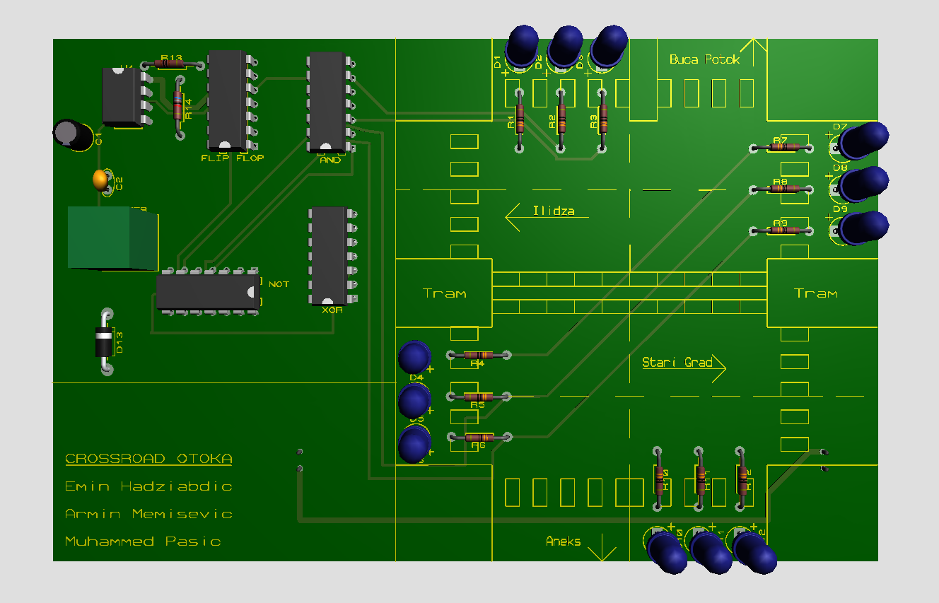
Figure 6 — 3D render of the fabricated board. Five DIP packages (74HCT74, 74HC08, 74HCT04, 74HCT86 and the NE555 at top left with its timing network R13, R14, C1 and C2), twelve LEDs arranged as four signal heads on a silkscreen map of the Otoka junction, twelve 330 Ω resistors, D13, and the single POWER screw terminal.
Conclusion. The Otoka controller was specified formally before it was built, and the five target properties were proven rather than tested. The layered approach mattered: no single model would have covered the whole requirement set. The LTS settled the graph-level questions cheaply, the Petri net produced the structural invariants and the decisive crash-unreachability result, LTL expressed the two genuinely temporal requirements and connected them to the gate equations, and the Markov model showed that safety is a property of the encoding rather than of fault-free operation. The design that came out of this process is also a cheap one: five DIP packages including the oscillator, no OR gates, and one XOR plus one inverter for the entire next-state logic. The fabricated board is the physical realisation of a controller whose critical properties were established mathematically beforehand.

6. Scope and known limitations
The following are stated explicitly rather than left implicit, since each is a boundary of what this project claims to have shown.
- Uniform phase duration. The oscillator is free-running and the state register is a plain 2-bit counter, so all four phases are equal in length: every state lasts exactly one oscillator period. Earlier design notes give unequal target durations for the four phases, longer for the two green intervals than for the two yellows. A single astable cannot produce that, and there is no prescaler or timer chain on the board. Realising unequal phases would require either a programmable clock source or additional counting logic to hold the green states for several oscillator periods, and neither was in scope. Nothing in the verification above depends on this, because every property in Section 4 is stated over clock steps rather than wall-clock time.
- The Markov argument is a robustness check, not an independent safety proof. The zero SCrash column follows from the state encoding rather than from the stochastic model. The 0.97 / 0.01 transition probabilities and the reward values are illustrative parameters chosen to exercise the model, not measurements of this hardware.
- The parts list distributed with the project predates the oscillator. It lists four ICs, twelve resistors, no capacitors and two screw terminals, whereas the schematic and PCB carry five ICs, fourteen resistors, two capacitors and one screw terminal. The schematic and board are the accurate record; the parts list has been corrected separately and should be read in that corrected form.
- The tram is not modelled. The PCB silkscreen depicts the tram lines that physically cross the Otoka junction, but the controller has no tram phase and the formal models contain no tram movement. Extending the FSM to include tram priority would require additional states and a wider state register, and is left as future work.
- The design uses no OR gates. The project proposal listed deriving AND/OR expressions among its objectives. The absence of OR gates is a result of the minimisation, not an omission: the up-count encoding reduces every output to a single minterm.
- No decoupling capacitors are specified. The two capacitors on the board, C1 and C2, both belong to the 555 timing network; neither provides local supply bypassing for the logic packages. Standard practice for HC/HCT logic switching twelve LEDs would place a 100 nF capacitor at each package. Their absence increases susceptibility to supply-rail disturbance, which is the physical phenomenon the Markov glitch model abstracts.
- Verification is at the logic level, not the electrical level. Every proof in Section 4 concerns Boolean and structural behaviour. LED drive currents, output voltage margins under load, and HC versus HCT input threshold compatibility were not formally analysed and are not claimed to be verified.

7. Figures to insert
All six figures are embedded; no placeholders remain.
# | Figure | Location in report | Source
1 | FSM state diagram with encoding and outputs | Section 3.1 | Drawn for this report
2 | State-sequence timeline over one cycle | Section 3.2 | Drawn for this report
3 | System block diagram | Section 3.5 | Drawn for this report
4 | Gate-level schematic | Section 3.5 | Proteus project export
5 | Petri net diagram (6 places, 4 transitions) | Section 4.2 | Formal verification working document
6 | PCB 3D render | Section 5 | Proteus 3D viewer export
Tables 1 to 7, including both K-maps, are generated directly in this document and need no external images. The reachability graph and the two Markov state diagrams that appear in the source verification document were deliberately omitted: the first duplicates Figure 1 and the second duplicates Table 6, and the assignment brief asks that redundant figures be avoided.

